# Simple Counter

***The plugin manages the "retry cycle" for errors and minimizes the number of operations to set it up.***

## Simple Counter

| **Item** | **Value** |
| --- | --- |
| Icon |  |
| Display Name | **Simple Counter** |

### Arun Kumar ([arunk@argos-labs.com](mailto:arunk@argos-labs.com))

* [email](mailto:arunk@argos-labs.com)

## Version Control

* 4.909.1314
* Release Date: September 7, 2022

## Input (Required)

| **Function type** | **Parameters** | **Output** |
| --- | --- | --- |
| Initialize | Start Number | (Output Text) |
|  | End Number |  |
|  | Increment |  |
| Count Up | Start Number (Output Initialize Function type) | (Output Text) |
|  | End Number |  |
|  | Increment |  |
| Count Down | Start Number (Output Initialize Function type) | (Output Text) |
|  | End Number |  |
|  | Increment |  |

Note:-

1. Increment always positive with Count Up.
2. Increment always negative with Count Down.
3. Count Up always from 1 to 99.
4. Count Down always 99 to 1.
5. Start Number and End Number must be non-zero.
6. Start Number and End Number zero case of fail return code 1.

Use for retry cycle: -

**Case: Integer (Count Up)**

Step-1: Choose To initialize Function type get Start Number (i.e. 1)

Step-2: choose Count Up Function type get Start Number (Output Initialize Function type) updated (i.e. 2), with return code 0 JumpToOperation or JumpToStep

Step-3: At the end of the event (i.e. 100), return code 1 in case of failure or modify it under the return code section.

## Return Value

### Normal Case

Description of the output result

## Return Code

| **Code** | **Meaning** |
| --- | --- |
| 0 | Success |
| 1 | Exceed retry cycle |
| 99 | Exceptional case |

## Output Format

You may choose one of 3 output formats below,

* String (default)
* CSV
* File

## Parameter setting examples (diagrams)

## Operations

### Initialize:

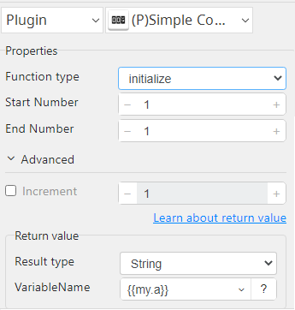

### Count Up:

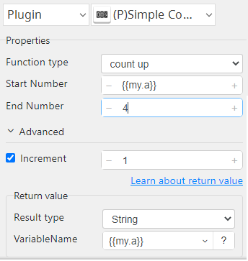

### Count Down:

